Module – 1 Lecture Notes – 3
Classification of Optimization Problems
Introduction
In the previous lecture we studied the basics of an optimization problem and its formulation as a mathematical programming problem. In this lecture we look at the various criteria for classification of optimization problems.
Optimization problems can be classified based on the
- type of constraints,
- nature of design variables,
- physical structure of the problem,
- nature of the equations involved,
- deterministic nature of the variables,
- permissible value of the design variables,
- separability of the functions and
- number of objective functions.

These classifications are briefly discussed below.
Classification based on existence of constraints.
Under this category optimizations problems can be classified into two groups as follows:
Constrained optimization problems: which are subject to one or more constraints.
Unconstrained optimization problems: in which no constraints exist.
Classification based on the nature of the design variables.
There are two broad categories in this classification.
(i) In the first category the objective is to find a set of design parameters that makes a prescribed function of these parameters minimum or maximum subject to certain constraints. For example to find the minimum weight design of a strip footing with two loads shown in Fig 1 (a) subject to a limitation on the maximum settlement of the structure can be stated as follows.
Find X = 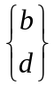 which minimizes
f(X) = h(b,d)
Subject to the constraints 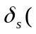X ) 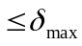; b 0 ; d 0
where 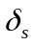 is the settlement of the footing. Such problems are called parameter or static optimization problems.
It may be noted that, for this particular example, the length of the footing (l), the loads P₁ and P₂ and the distance between the loads are assumed to be constant and the required optimization is achieved by varying b and d.
(ii) In the second category of problems, the objective is to find a set of design parameters, which are all continuous functions of some other parameter that minimizes an objective function subject to a set of constraints. If the cross sectional dimensions of the rectangular footings are allowed to vary along its length as shown in Fig 3.1 (b), the optimization problem can be stated as :
Find X(t) = 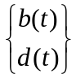 which minimizes
f(X) = g( b(t), d(t) )
Subject to the constraints
X(t) ) 0 t l
b(t) 0 0 t l
d(t) 0 0 t l
The length of the footing (l) the loads P₁ and P₂ , the distance between the loads are assumed to be constant and the required optimization is achieved by varying b and d along the length l.
Here the design variables are functions of the length parameter t. this type of problem, where each design variable is a function of one or more parameters, is known as trajectory or dynamic optimization problem.
l
l
P₁
P₂
d
b
P₂
P₁
b(t)
d(t)
t
(a) (b)
Figure 1
Classification based on the physical structure of the problem
Based on the physical structure, optimization problems are classified as optimal control and non-optimal control problems.
(i) Optimal control problems
An optimal control (OC) problem is a mathematical programming problem involving a number of stages, where each stage evolves from the preceding stage in a prescribed manner. It is defined by two types of variables: the control or design and state variables. The control variables define the system and controls how one stage evolves into the next. The state variables describe the behavior or status of the system at any stage. The problem is to find a set of control variables such that the total objective function (also known as the performance index, PI) over all stages is minimized, subject to a set of constraints on the control and state variables. An OC problem can be stated as follows:
Find X which minimizes f(X) = 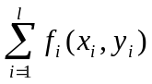
Subject to the constraints
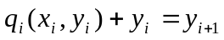 i = 1, 2, …., l
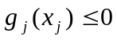, j = 1, 2, …., l
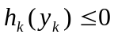, k = 1, 2, …., l
Where x_{i} is the ith control variable, y_{i} is the ith state variable, and f_{i} is the contribution of the ith stage to the total objective function. g_{j}, h_{k}, and q_{i} are the functions of x_{j,} y_{j ;} x_{k,} y_{k} and x_{i} and y_{i}, respectively, and l is the total number of states. The control and state variables x_{i} and y_{i} can be vectors in some cases.
(ii) Problems which are not optimal control problems are called non-optimal control problems.
Classification based on the nature of the equations involved
Based on the nature of equations for the objective function and the constraints, optimization problems can be classified as linear, nonlinear, geometric and quadratic programming problems. The classification is very useful from a computational point of view since many predefined special methods are available for effective solution of a particular type of problem.
(i) Linear programming problem
If the objective function and all the constraints are ‘linear’ functions of the design variables, the optimization problem is called a linear programming problem (LPP). A linear programming problem is often stated in the standard form :
Find X = 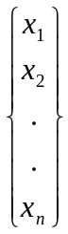
Which maximizes f(X) = 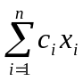
Subject to the constraints
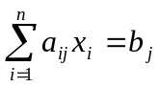, j = 1, 2, . . . , m
x_{i} 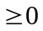, j = 1, 2, . . . , m
where c_{i}, a_{ij}, and b_{j} are constants.

(ii) Nonlinear programming problem
If any of the functions among the objectives and constraint functions is nonlinear, the problem is called a nonlinear programming (NLP) problem. This is the most general form of a programming problem and all other problems can be considered as special cases of the NLP problem.
(iii) Geometric programming problem
A geometric programming (GMP) problem is one in which the objective function and constraints are expressed as polynomials in X. A function h(X) is called a polynomial (with terms) if h can be expressed as
where c_{j} (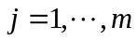) and a_{ij} (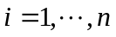 and ) are constants with 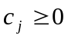 and 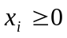.
Thus GMP problems can be posed as follows:
Find X which minimizes
f(X) = 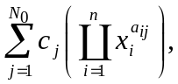 c_{j} > 0, x_{i} > 0

subject to
g_{k}(X) = 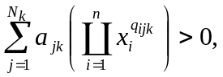 a_{jk} > 0, x_{i} > 0, k = 1,2,…..,m
where N₀ and N_{k} denote the number of terms in the objective function and in the k^{th} constraint function, respectively.
(iv) Quadratic programming problem
A quadratic programming problem is the best behaved nonlinear programming problem with a quadratic objective function and linear constraints and is concave (for maximization problems). It can be solved by suitably modifying the linear programming techniques. It is usually formulated as follows:

F(X) = 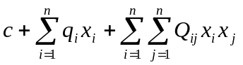
Subject to
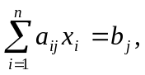 j = 1,2,….,m
x_{i} , i = 1,2,….,n
where c, q_{i}, Q_{ij}, a_{ij}, and b_{j} are constants.
Classification based on the permissible values of the decision variables
Under this classification, objective functions can be classified as integer and real-valued programming problems.
(i) Integer programming problem
If some or all of the design variables of an optimization problem are restricted to take only integer (or discrete) values, the problem is called an integer programming problem. For example, the optimization is to find number of articles needed for an operation with least effort. Thus, minimization of the effort required for the operation being the objective, the decision variables, i.e. the number of articles used can take only integer values. Other restrictions on minimum and maximum number of usable resources may be imposed.
(ii) Real-valued programming problem
A real-valued problem is that in which it is sought to minimize or maximize a real function by systematically choosing the values of real variables from within an allowed set. When the allowed set contains only real values, it is called a real-valued programming problem.
Classification based on deterministic nature of the variables
Under this classification, optimization problems can be classified as deterministic or stochastic programming problems.
(i) Stochastic programming problem
In this type of an optimization problem, some or all the design variables are expressed probabilistically (non-deterministic or stochastic). For example estimates of life span of structures which have probabilistic inputs of the concrete strength and load capacity is a stochastic programming problem as one can only estimate stochastically the life span of the structure.
(ii) Deterministic programming problem
In this type of problems all the design variables are deterministic.

Classification based on separability of the functions
Based on this classification, optimization problems can be classified as separable and non-separable programming problems based on the separability of the objective and constraint functions.
(i) Separable programming problems
In this type of a problem the objective function and the constraints are separable. A function is said to be separable if it can be expressed as the sum of n single-variable functions, 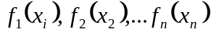, i.e.
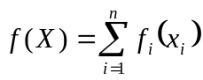
and separable programming problem can be expressed in standard form as :
Find X which minimizes
subject to
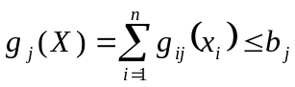 , j = 1,2,. . . , m
where b_{j} is a constant.
Classification based on the number of objective functions
Under this classification, objective functions can be classified as single-objective and multi-objective programming problems.
(i) Single-objective programming problem in which there is only a single objective function.
(ii) Multi-objective programming problem
A multiobjective programming problem can be stated as follows:
Find X which minimizes 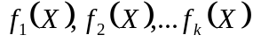
Subject to
g_{j}(X) 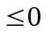, j = 1, 2, . . . , m
where f₁, f₂, . . . f_{k} denote the objective functions to be minimized simultaneously.
For example in some design problems one might have to minimize the cost and weight of the structural member for economy and, at the same time, maximize the load carrying capacity under the given constraints.

